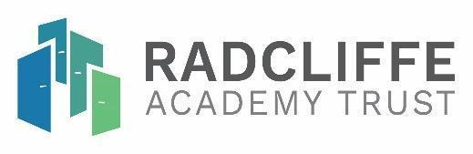
Joining River Learning Trust
Formal consultation response form

The consultation starts at 0900 on 20th June 2024
and closes at 0900 on 18th July 2024

Please return your consultation form by email to hayden.davies@meadowbrookcollege.org or by post or by hand to RLT Academy Consultation, Meadowbrook College,Raymund Road,
Oxford OX3 0FS
Name (optional):

Please highlight the category/categories that best describe your connection to Meadowbrook College:

Meadowbrook College respondents

Parent or Carer Student Staff Trustee/governor

Other respondents

Parent./Carer School member of staff Local authority member of staff Chair of Trust/governor

Having considered all the information that has been made available to you about the consultation for Meadowbrook College, please respond to the following:

1) What concerns or queries do you have about the possibility that Meadowbrook College may join the River Learning Trust?

2) What possible benefits or opportunities do you see for Meadowbrook College should it join as part of the River Learning Trust?

3) What further queries or comments (if any) do you have regarding the possibility that Meadowbrook College may join to be part of the River Learning Trust?

Thank you for participating in this consultation.

