VOCATIONAL TRAINING
Certificate/ Diploma in BTEC Hair & Beauty
Course Information
Programme Outline: This is a modular approach to our vocational training courses and is offered to YR10 and YR11 students, giving them the opportunity to study within a Vocational setting. Each module will be 6 weeks long X 1 day per week. Certificate can be achieved in 24 weeks and the Diploma in 30 weeks.

Course Duration: 6 Weeks per module. Times: 9am - 2pm.
Location: The Harlow Centre.
Course Content: Units will be selected from BTEC Hair & Beauty.

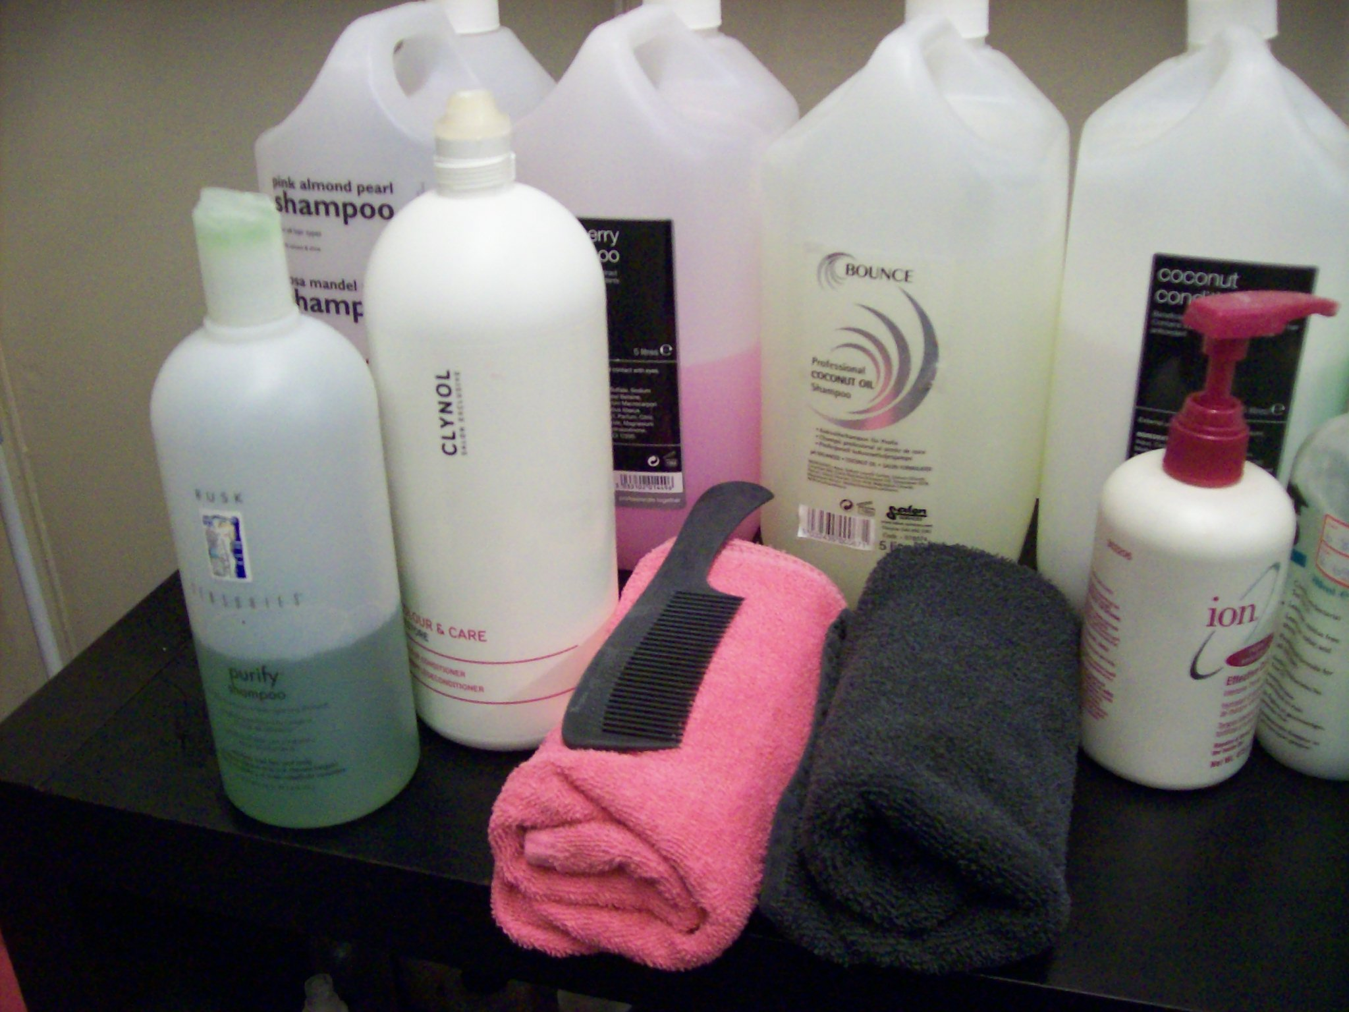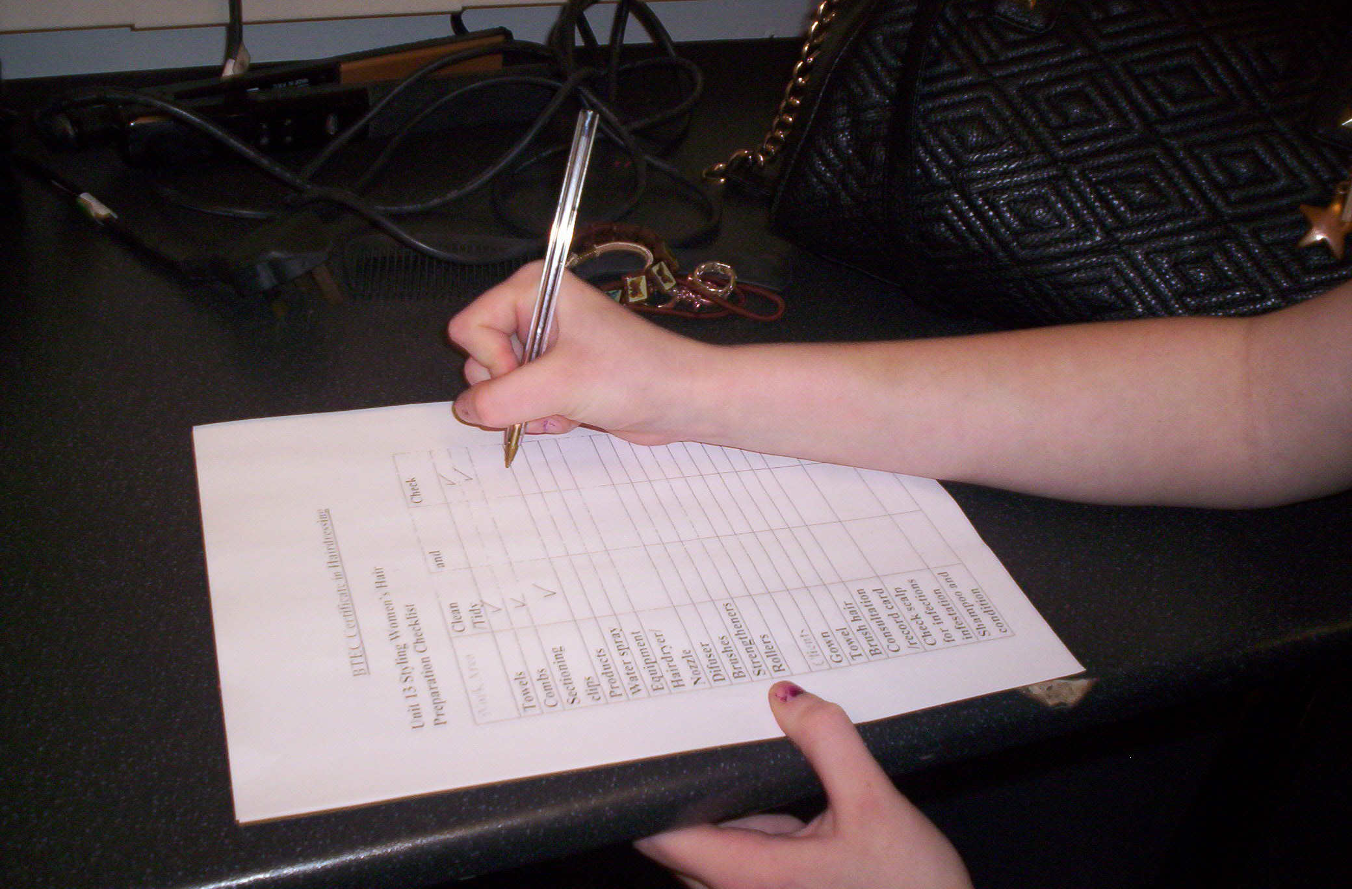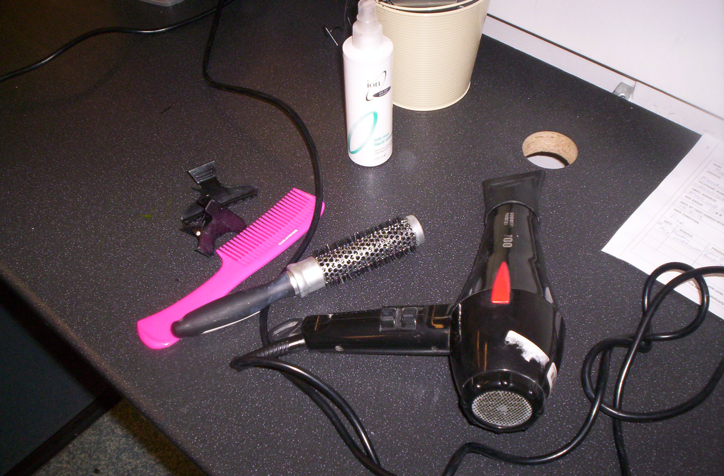
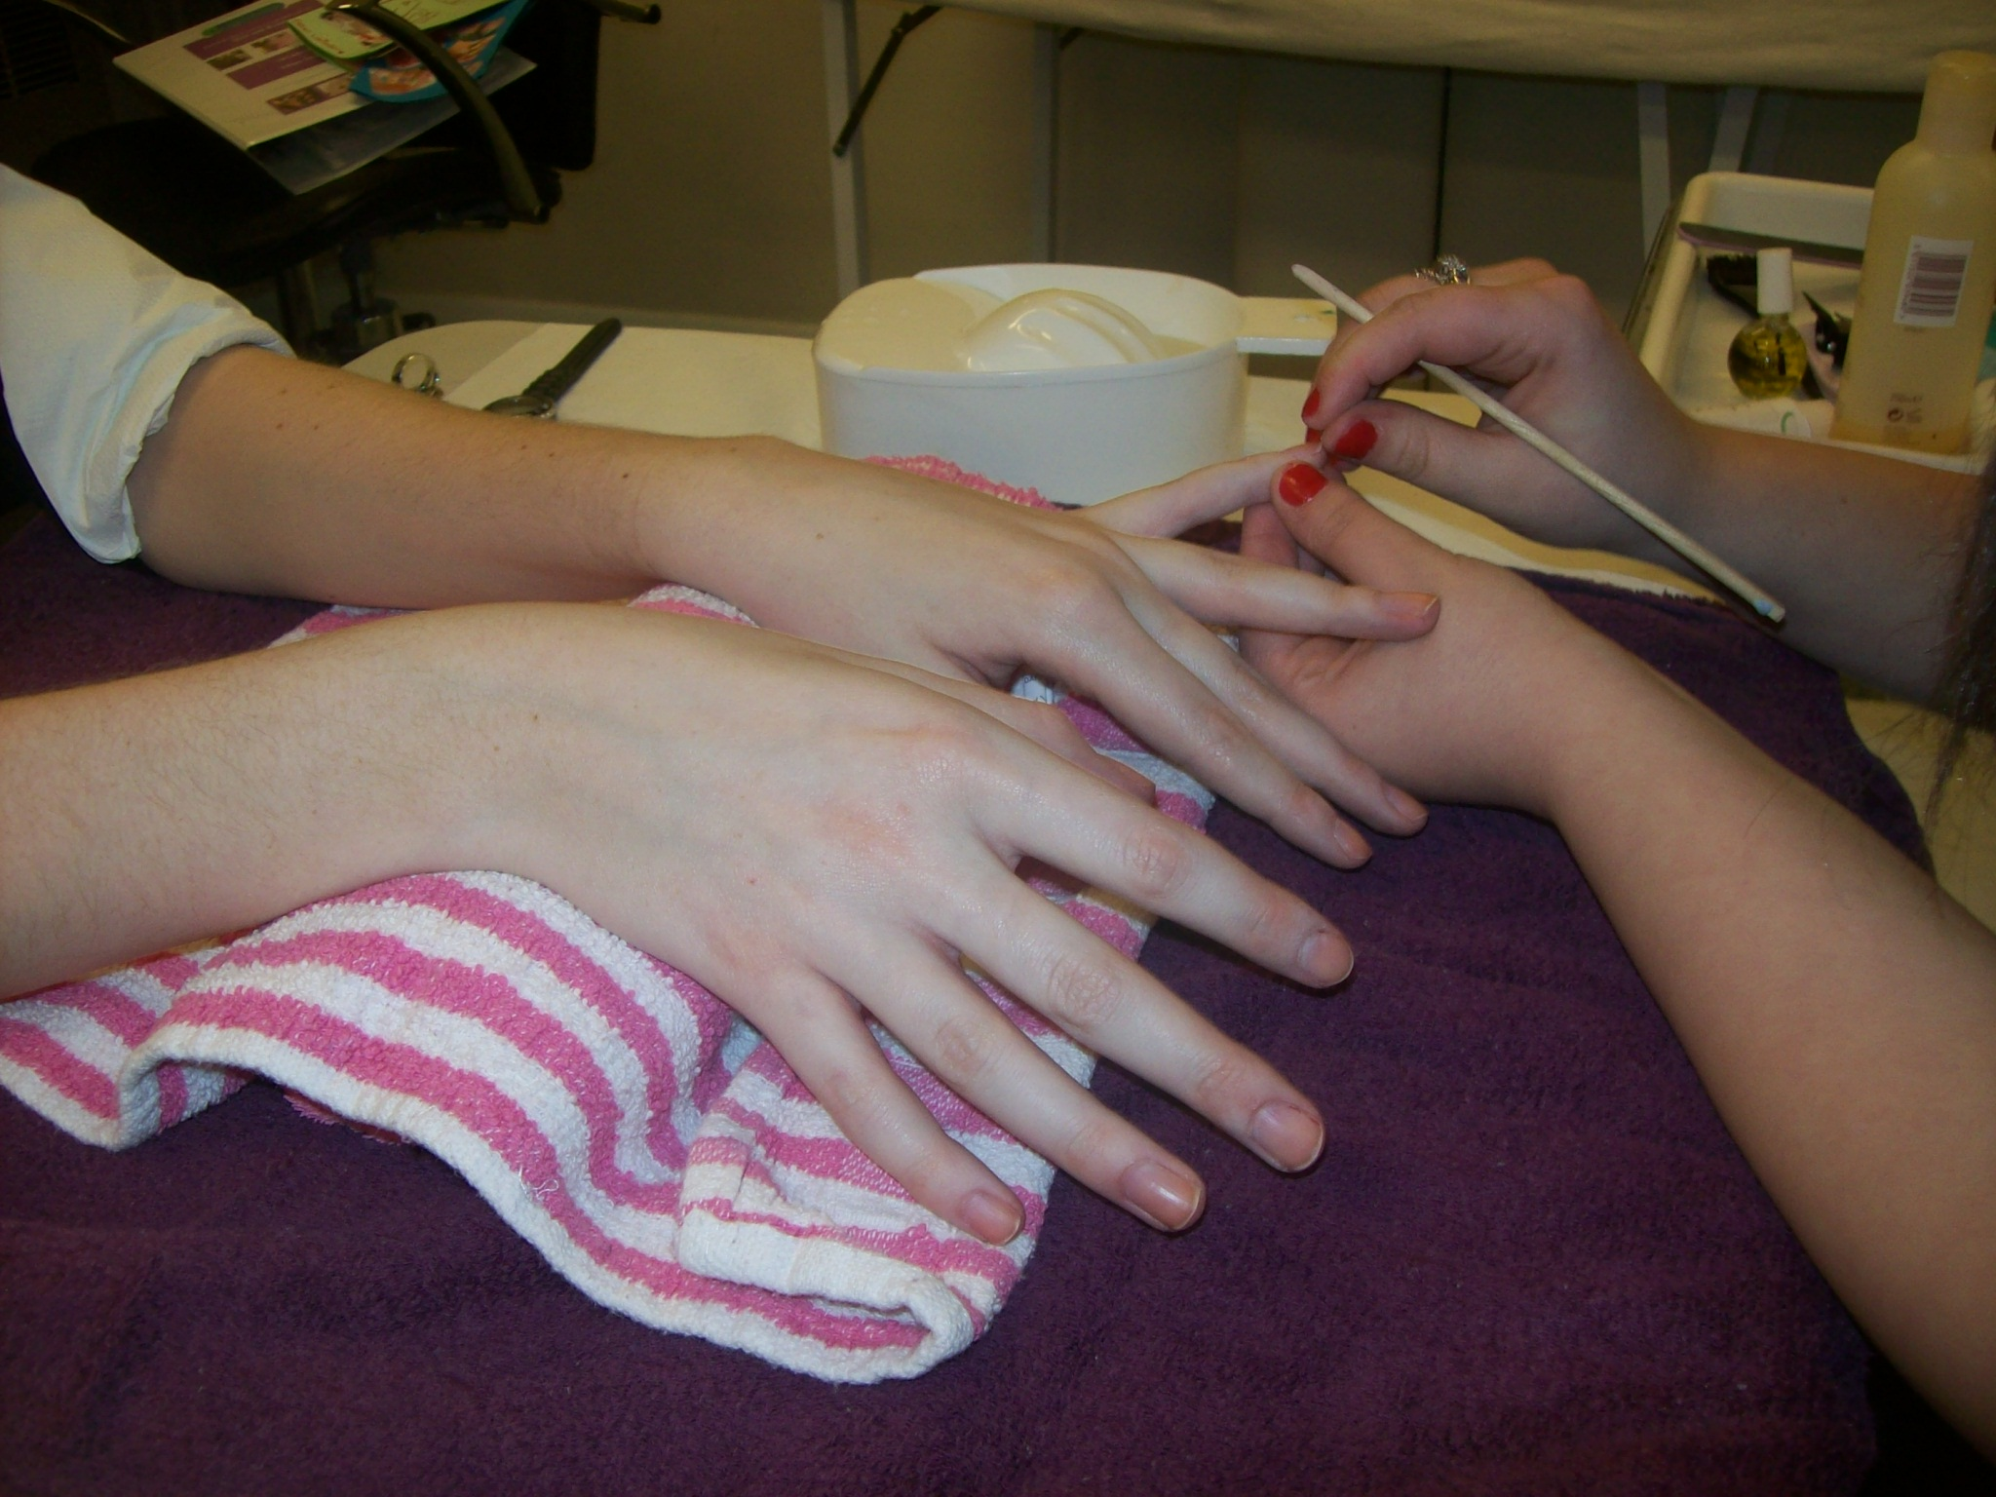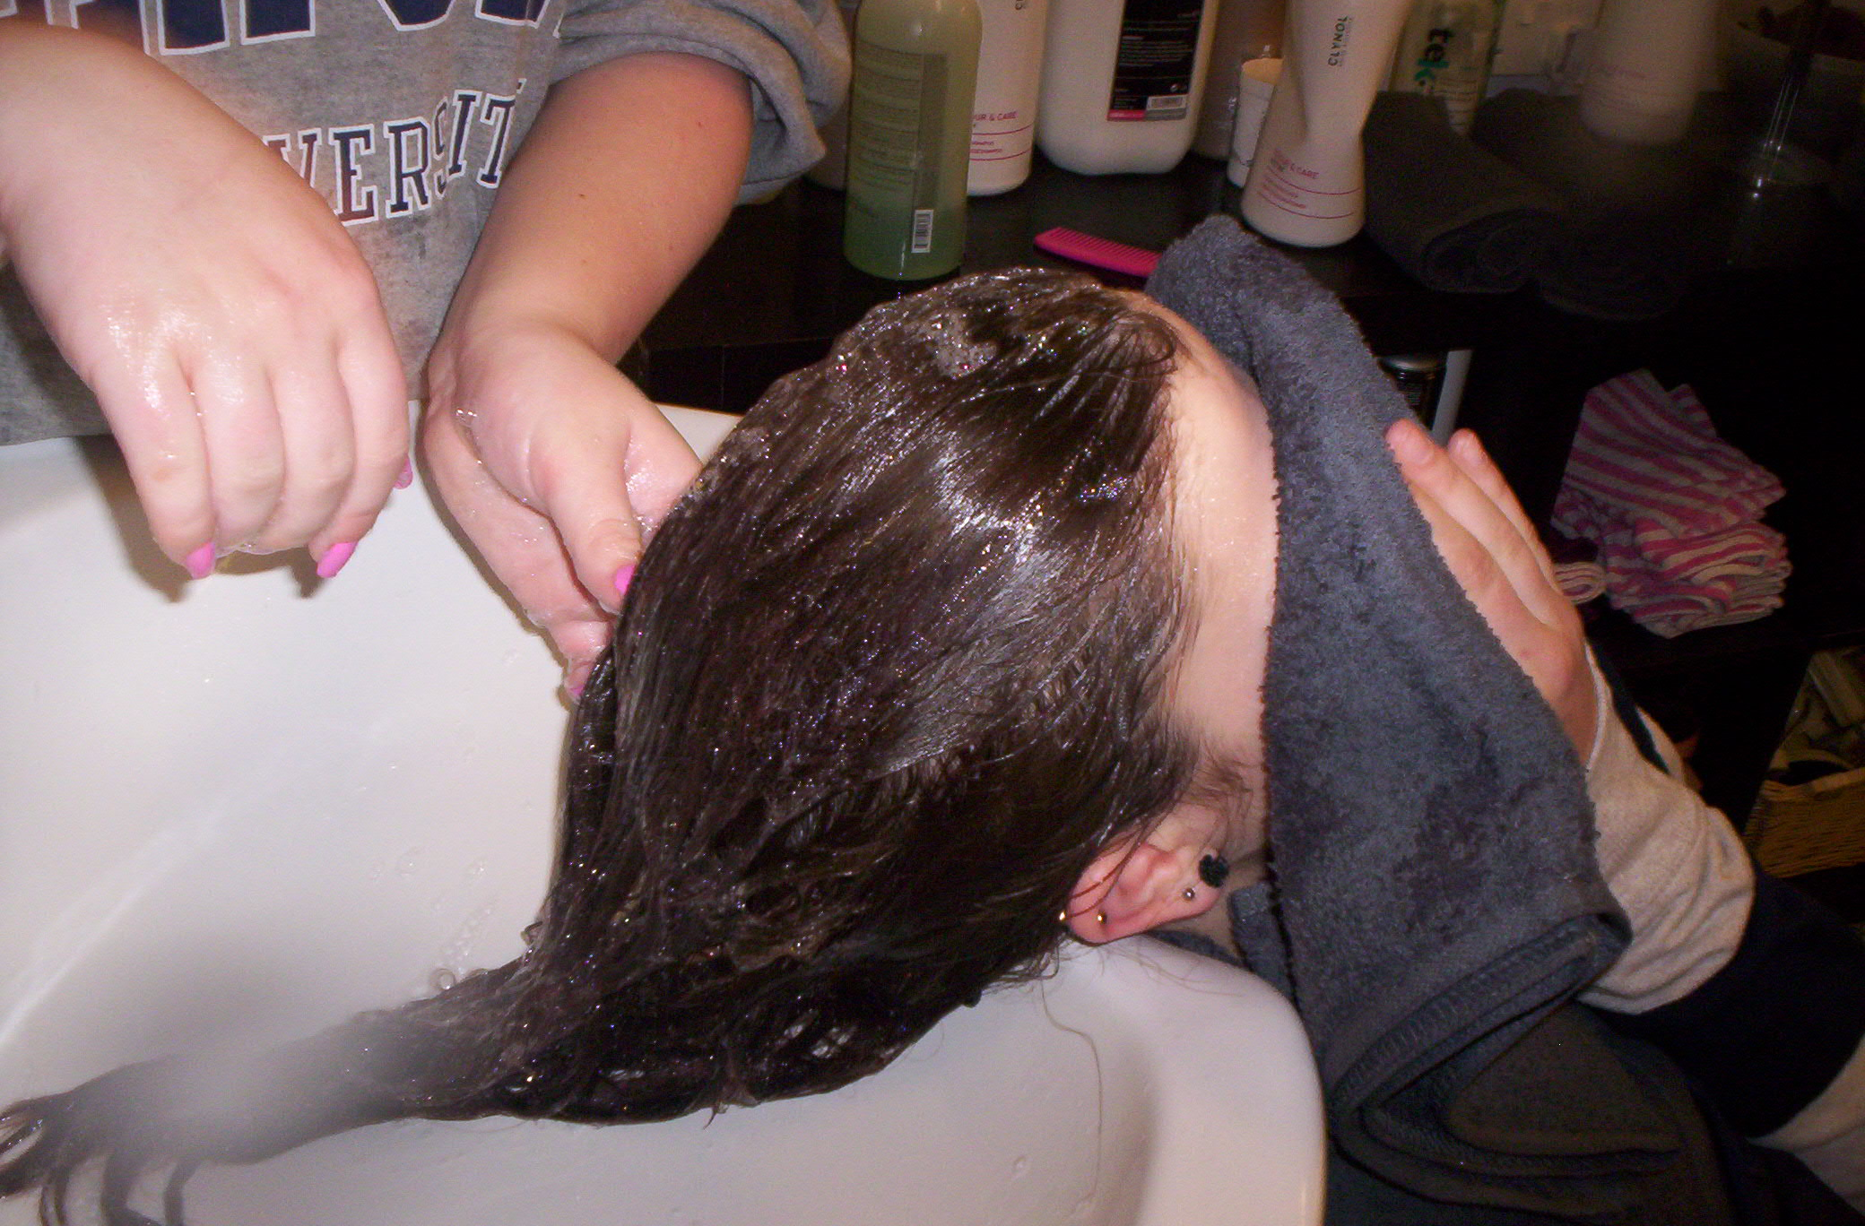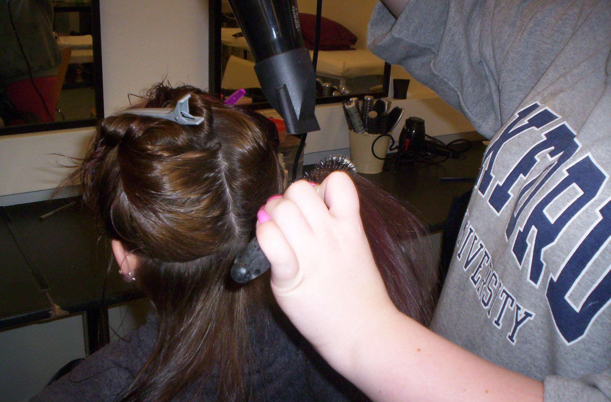
Course Contact:. Jessie Dobson
Referral Procedures and for further information:
Tel: 01865 253198
Email: jdobson@meadowbrook.oxon.sch.uk
ghubbucks@meadowbrook.oxon.sch.uk

